Execute the following network commands like ipconfig, tracert, telnet, netsh, ping, nslookup, netstat

**PROCEDURE:-**

***STEP 1 :*** Launch the cisco packet tracer

Double click the cisco packet tracer icon on your desktop or find it in your applications list and open the program

***STEP 2:*** Create a simple network topology

1.Add devices

(i)Routers and switches

(ii)Drag and drop a router and a switch from the device list on to the workspace

(iii)Drag and drop two pcs onto the workspace

2. Connect devices

Use the connection tool to connect the devices

(i)Connect one pc to the switch using the copper straight -through cable

(ii)Connect the switch to the router using another copper straight- through cable

(iii)Connect the second pc to the switch using copper straight- through cable

***STEP 3:*** Configure Devices :

(i)Configure the router

(ii)Click on the router

(iii)Go to config tab

(iv)Assign ip address to the router interfaces

**Example:-** PC 0:inerfaceG0/0:ip address 192.168.1.1,subnet mask:255.255.255.0

PC1 :inerfaceG0/0:ip address 192.168.1.1,subnet mask:255.255.255.0

(ii)Configure the pcs

Click on each pc go to the desktop option and the ip configuration

Assign ip address to each pc

**Example :-** PC0: IP address 192.168.1.2,subnet mask 255.255.255.0,Default gateway : 192.168.1.1

PC1: IP address 192.168.1.2,subnet mask 255.255.255.0,Default gateway : 192.168.2.1

***STEP 4:*** Execute networking commands

1. Open the command prompt on PC0
2. Click on a pc 0
3. Go the desktop tab and open the command prompt
4. **Ip config**

This command displays all current tcb ip network config values and all dhcp and dns settings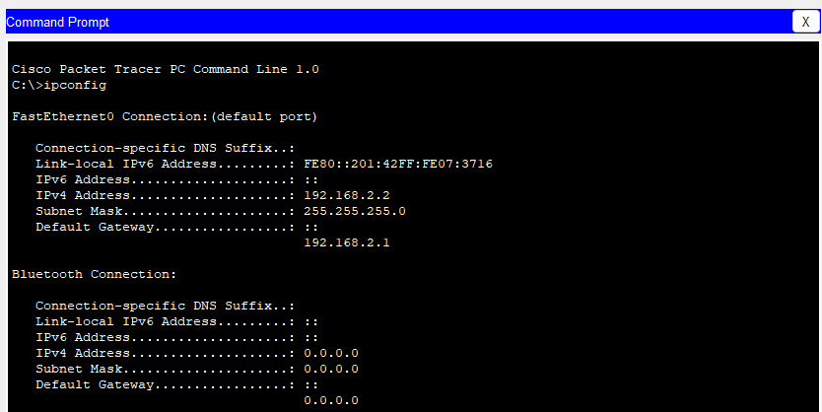

This command tracers the path taken to a destination by sending icmp echo request messages

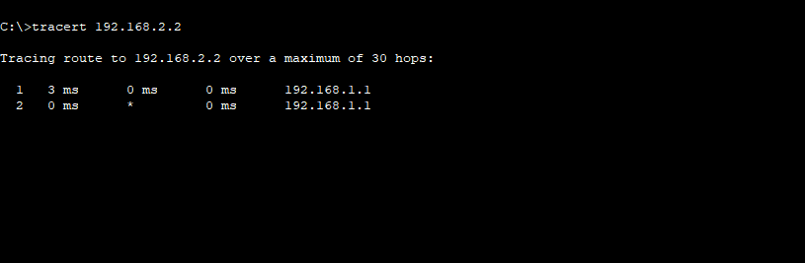

**Configure the Router**

1. **Assign IP Address:**

o Click on the router.

1. Go to the Config tab.

o Select the interface connected to the switch (e.g., G0/0).

o Assign IP address: 192.168.1.1, Subnet Mask: 255.255.255.0

Router>enable

Router>configure terminal Router(config-if)#line vty 0 4

Router(config-line)#password cisco

Router(config-line)#login

Router(config-line)#exit Router(config)#end

Router#

%SYS-5-CONFIG_I: Configured from console by console

Router#write memory

Building configuration...

[OK]

Router (config-if)#line vty 0 4

Router (config-line)#password cisco

Router (config-line)#login

Router (config-line)#exit |

Router (config) #end

Router#

Office

SYS-5-CONFIG_I: Configured from console by console

Router#write memory

Building configuration... [OK]

Pnable

Telnet from PC to Router

1. **Open Command Prompt:**

o On the PCO, go to the Desktop tab and open the Command Prompt.

2. **Execute Telnet Command:**

telnet <destination IP> <port>

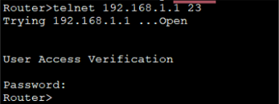

Telnet Security: Telnet is an unencrypted protocol and is not secure. For real-world applications, consider using SSH for secure remote connections.

Enabling Telnet on a Real Router: If using real equipment, make sure Telnet is enabled and the device is configured to accept Telnet connections.

1. Router configuration and Brief Ip Interface

This command is a scripting utility that allows you to display or modify the network configuration of a computer.

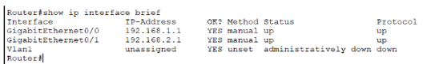

5. Ping 192.168.2.2

ICMP Echo

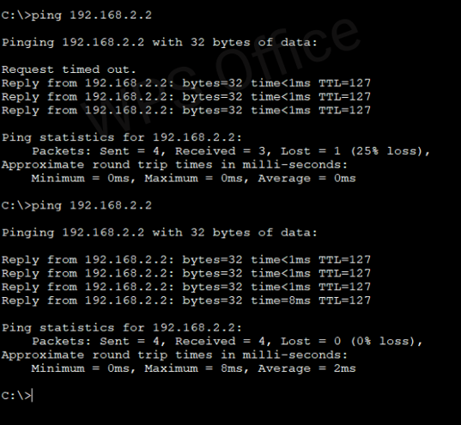

6. **nslookup**

**nslookup** [www.google.com](http://www.google.com)

This command queries the DNS to obtain domain name or IP address mapping.

To use the nslookup command to resolve a domain name to an IP address in Cisco Packet Tracer, you'll need to ensure that the DNS server is properly configured in your network topology.

1.Add one server (to act as a DNS server).

2. Connect both PCs and the server to the switch using copper straight-through cables.

Configure the DNS Server

1. **Assign IP Address:**

o Click on the server.

O

о

Go to the Config tab and select the FastEthernet0 interface.

Assign IP address: 192.168.1.3, Subnet Mask: 255.255.255.0, Default Gateway: 192.168.1.1.

**Configure DNS Service:**

Go to the Services tab on the server.

Select DNS and turn the service On.

Add an entry for www.google.com with an IP address (e.g., 8.8.8.8).

Use the nslookup Command

1. **Open Command Prompt on PCO:**

o Go to the Desktop tab on PCO.

o Open the Command Prompt.

2. **Execute the nslookup Command:**

3. **nslookup** [www.google.com](http://www.google.com)

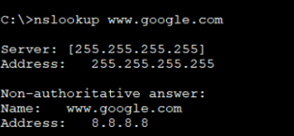

This indicates that the PC successfully queried the DNS server and resolved the domain name www.google.com to the IP address 8.8.8.8.

**DNS Server Configuration:** Ensure that the DNS server is correctly configured and running.

**DNS Entries:** The DNS entry for www.google.com should be added to the DNS server with an IP address.

**Network Configuration:** Ensure that all devices are correctly connected and configured with appropriate IP addresses, subnet masks, and default gateways.

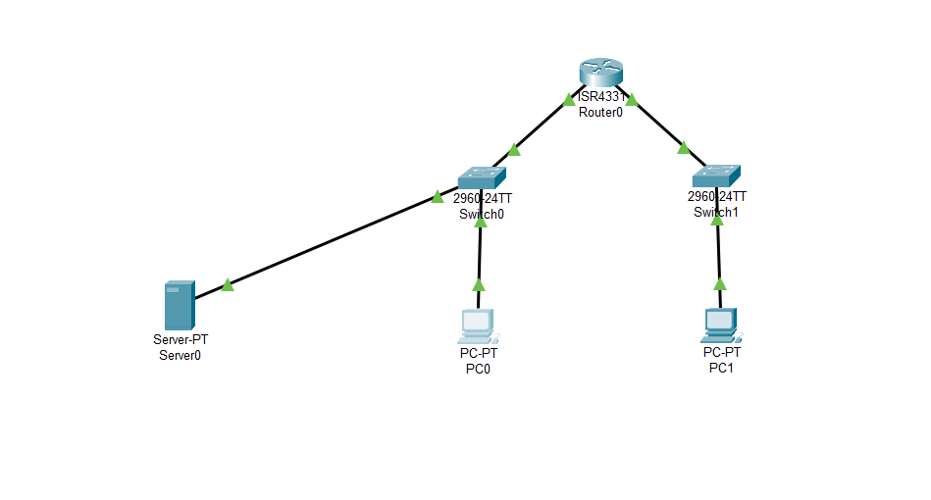

7. **Netstat**

This command displays network connections for the Transmission Control Protocol (TCP), routing tables, and a number of network interface and network protocol statistics.

The netstat command is used to display network connections, routing tables, interface statistics, masquerade connections, and multicast memberships.